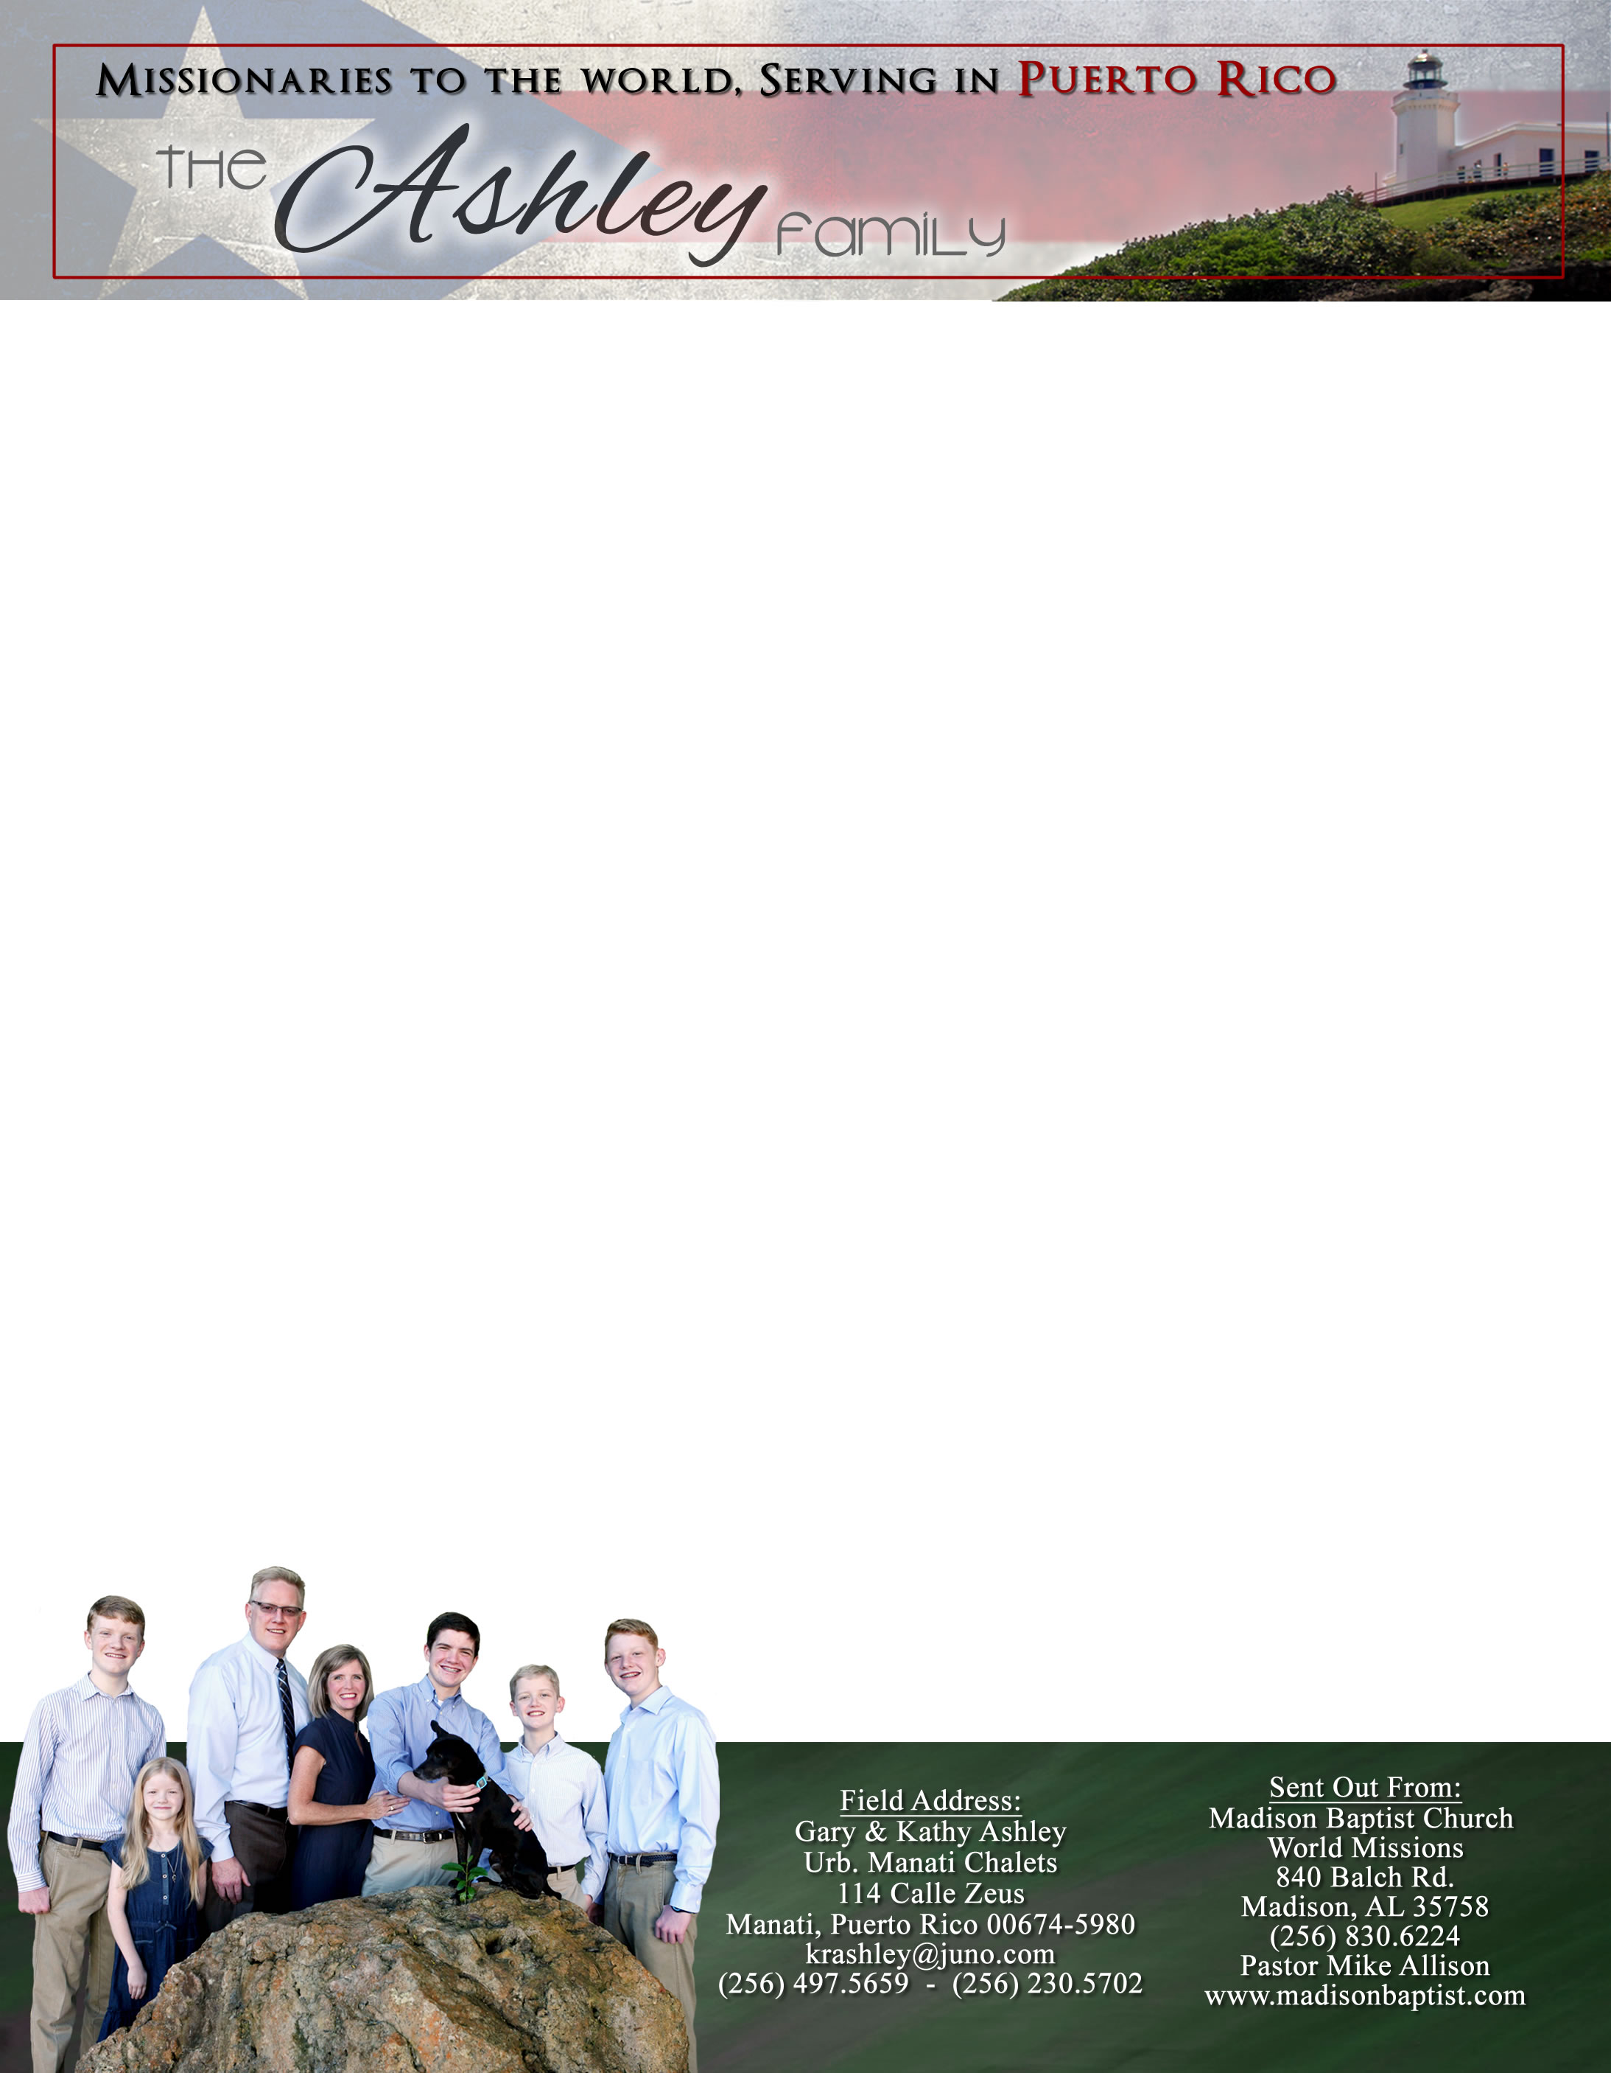

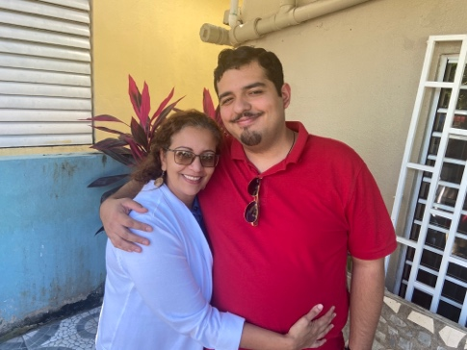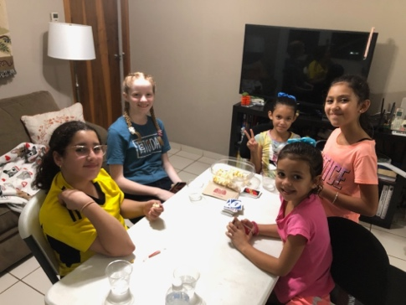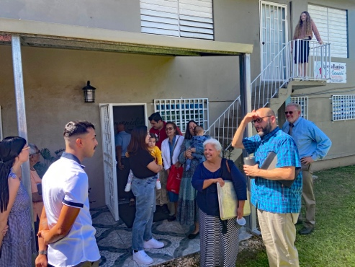

New girls for Girls’ Club!

Rosemary with her son Andre

Visitors on Sunday

Dear Praying Friends, November / December 2022

**Genesis 3:15 “And I will put enmity between thee and the woman, and between thy seed and her seed: it shall bruise thy head, and thou shalt bruise his heel.”**

This is often called the proto-evangelion since it is the first mention of the evangel, Jesus coming in the incarnation, in the flesh. It prophesied that God will maintain this conflict of her seed and Satan. Jesus came as our Mediator. He could do this since He is 100% God and 100% human. His entire human life from conception to ascension is a public life because He lived as our Mediator. Do not forget the incarnation at Christmas time because our salvation is because of our union to the entire person of Jesus by faith in Jesus. This means that all He is and did as a human is gifted to us in Christ. That gift is the story of the ages; celebrate this great event! Merry Christmas!

As we reflect on this year, we have so many praises. Our missionary from Venezuela, Klixon Castillo, was able to visit us and our church as he was making his rounds to other churches. This was a great encouragement to all of us as we listened to the work that God is doing in Valencia. We also praise the Lord that even with the high inflation that we are experiencing, the people of our church want to send to Klixon and Luis Quilarque gifts for Christmas to help them out in their ministries there. We also praise the Lord that we were able to purchase some new Baptist hymnals for the church to allow us to sing a more diverse selection of hymns. We had these hymnals before Hurricane Maria, but they had to be discarded because of the flooding. Once again God has replenished what was lost.

Please pray for Ileana. She needed a job, and we prayed for one for her, but since she got a job, she has found it difficult to come to church. Also, please remember Juana in your prayers; she is in the stages of dementia. Though she comes faithfully, she cannot remember very much. Merry Christmas!

*Alaba al Señor*,

(Praise the Lord)

Gary Ashley