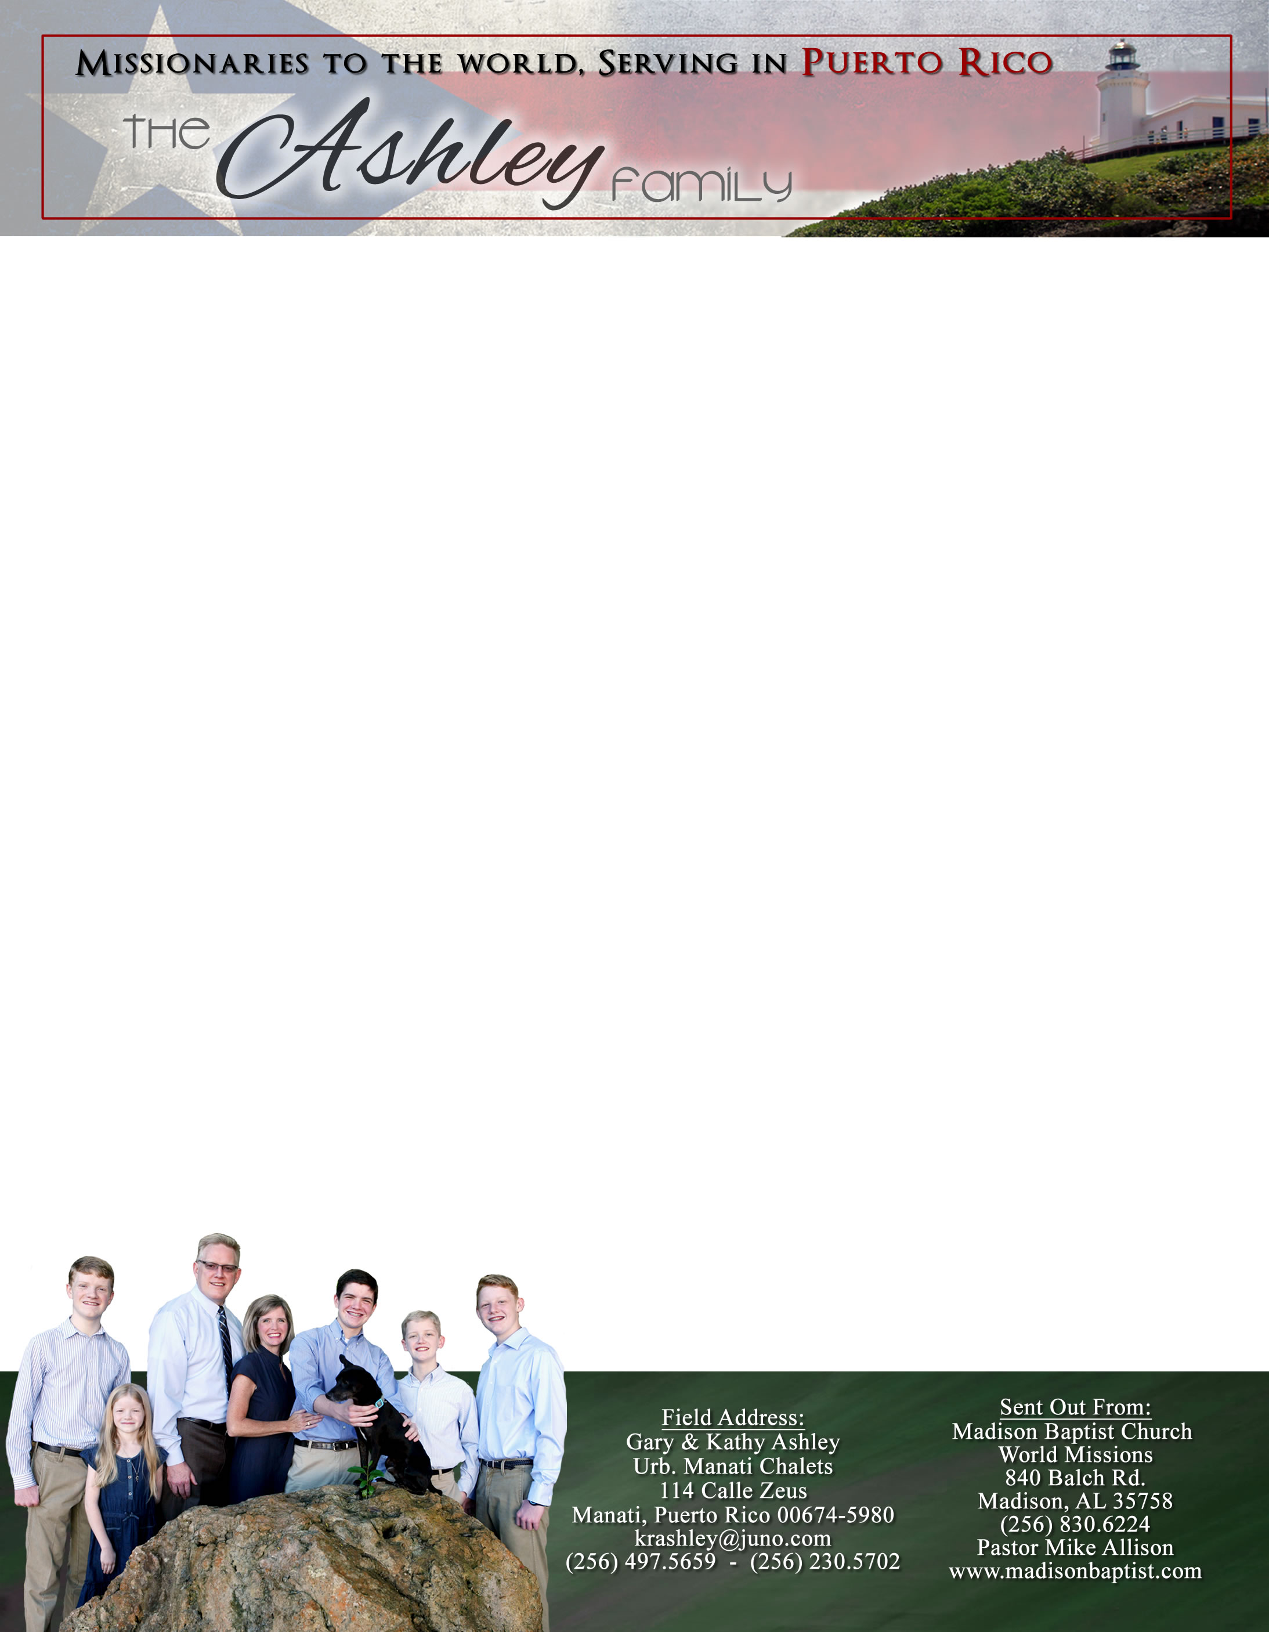

*Alaba al Señor*,

(Praise the Lord)

Gary Ashley

Dear Praying Friends, March / April 2022

**Proverbs 25:25 says, “As cold waters to a thirsty soul, so is good news from a far country.”**

Often in news reports today it is continually sad and tragic news; and at other times, the good news has little content and is unspecific. We sit waiting and hoping for any news that could refresh and give us that proverbial light at the end of the tunnel. Thankfully, God has given His Word which is full of hope and refreshing water to our thirsty souls!

We are excited that Klixon Castillo, our missionary in Venezuela (who, in a sense, is my Timothy in the ministry from our years spent in Venezuela) is flying to the states to report on his work and raise more support. His church website is the following: https://ibbvalencia.com If you would be interested in his coming to visit your church, please contact me and I can relay the message to him. He is also planning to fly here to Puerto Rico to visit our church and meet the people here who have supported him for several years. This is also good news from a far country to us!

Praise the Lord that finally the fear of Covid has calmed here in Puerto Rico. That has been a cold refreshment to us as well. We continue to go on church wide visitation and pass out tracts. We pray that the Lord will bless these efforts as we share the great Good News with people here in Manatí.

Lastly, we have great news. Kathy has written and published two books through the Sword of the Lord publishers: *Vitamins for the Soul* and *Call Upon Him*. They were written for women as study helps; they are full of content and very specific. The first book is a challenge to grow in the grace of our Lord Jesus Christ from 2nd Peter and the second is a heartfelt series about the importance of prayer through the perspective of the prayers of people in Scripture. Perhaps they could be a refreshment to the hearts of the women in your church as well. We are just missionaries in a far country sending back a few reports each year; but in this way, the women can see into Kathy’s heart as she pursues God and maybe understand more about the life of a missionary’s wife as well as grow in the Christian walk. We often ask God, “Who are we that God should allow us a

greater expansion of our ministry?” Yet, these books give us

an opportunity to help not just our church here in Manatí and

our community but also encourage and give hope to those in

other places. God bless you all as you serve Him!