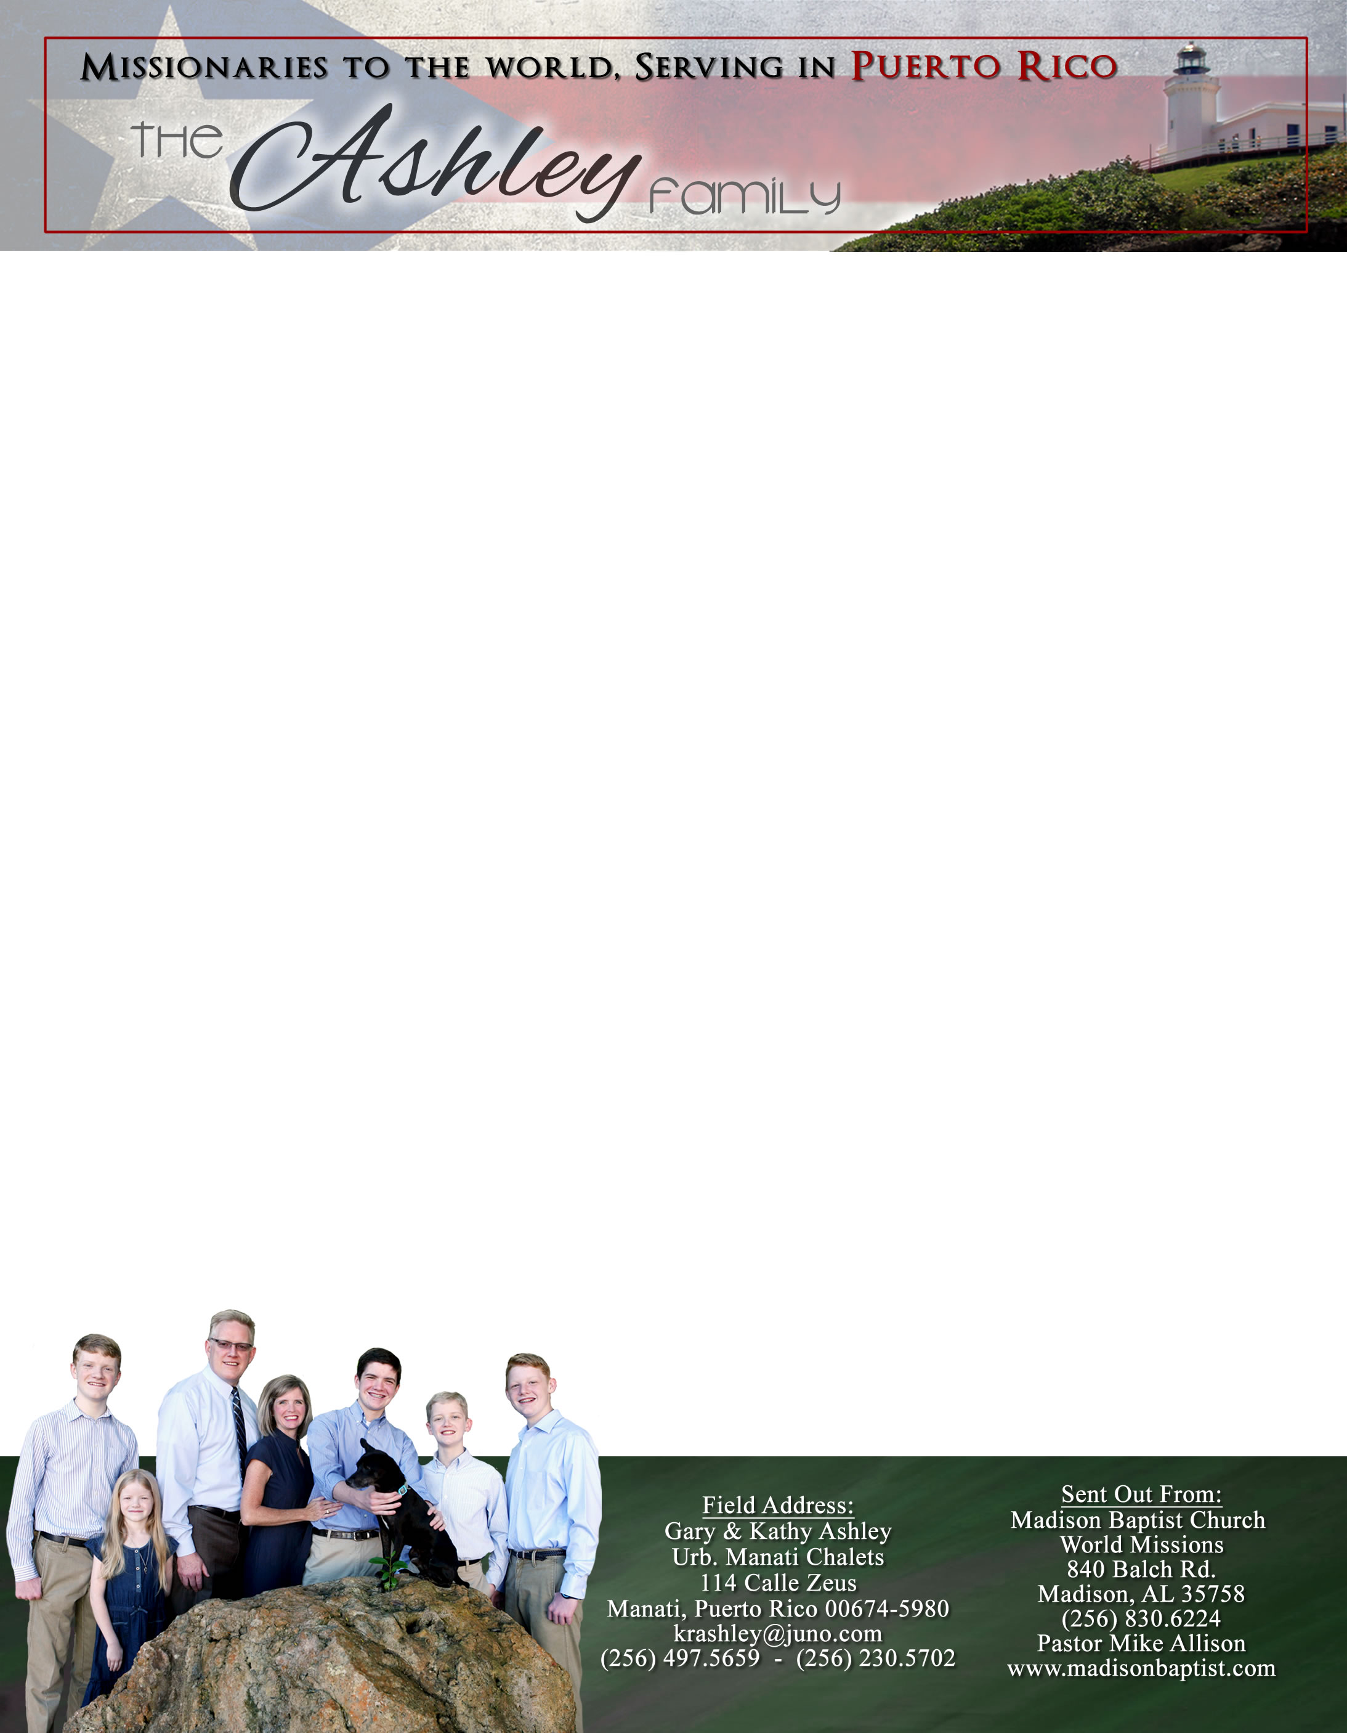 **Andrew & Freddy**

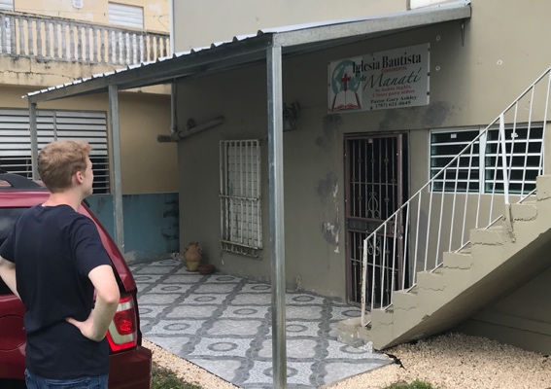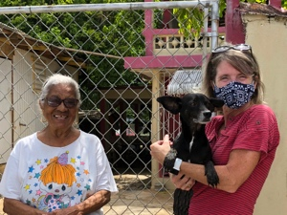

*Alaba al Señor*,

(Praise the Lord)

Gary Ashley

Praise the Lord that some have recognized that need and in these trying times have turned even more toward God. We pray that more would have that same desire and want to restart visitation. We want to give a clear testimony and not just signal our virtue. We have continued to visit each week, carefully, but joyfully.

We praise the Lord that we have been able to advance the reconstruction of the building by tearing down the old patio that was battered and have restored it with a new one that, Lord willing, is hurricane-proof. The few that have been able to come have a great spirit and want to continue to rebuild and to praise God in the midst of this panic/fear.

Dear Praying Friends, July / August 2020

**Revelation 5:9 says, “And they sung a new song, saying, Thou art worthy to take the book, and to open the seals thereof: for thou wast slain, and hast redeemed us to God by thy blood out of every kindred, and tongue, and people, and nation.”**

Because of these times, people are concerned with the balance between health and freedom; this has caused a new term to be formed, virtue signaling. We know that we all stand as sinners, void of any virtue; we have come short of the glory of God. There is only One alone who is virtuous and worthy, and One alone who can unite the former enemies because of ethnic animosity as His bride. We must not allow ourselves to be sidetracked by lesser messages or even wicked anti-Christian doctrines but rather faithfully follow our King and Head of the church by singing loudly the hymns of the faith to the glory of our Great God. We have a new song and these songs are not so much about the liberation but more so about the Liberator.

Praise the Lord that Klixon Castillo in Venezuela has been able to buy a motor scooter and has enough gas to visit the members. He has also been able to do community services even though they are not allowed to meet all together in the building. As a kid, I marveled over the underground services of Bro. Andrew in *God’s Smuggler* as he ministered in communistic and dictatorial lands. Pray that we be that light set on a hill that we should be and that this encourages others to stand as well. God is still in control! What a great God we serve!