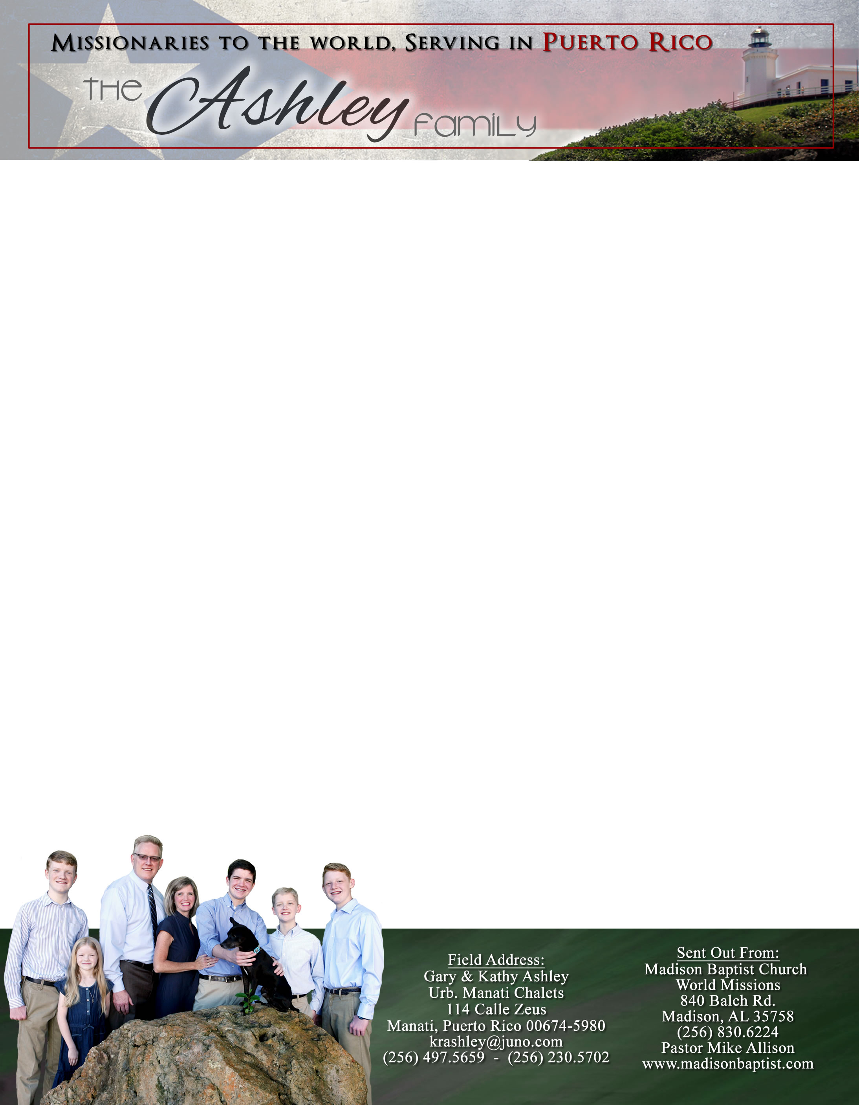 **Andrew & Freddy**

*Alaba al Señor*,

(Praise the Lord)

Gary Ashley

Dear Praying Friends, July / August 2021

**I Chronicles 11:14 says, “And they set themselves in the midst of that parcel, and delivered it, and slew the Philistines; and the LORD saved them by a great deliverance.”**

Saul was the foil for David; Saul and all his house died in 10:6 and David waxed greater and greater in 11:9. This was evidenced by the mighty men of valor that came to him. Eleazer and David stood in a field of barley – a nondescript parcel of land that they held for Israel and God, and God delivered them. Who was Eleazer, what field, and what were the names of these great combatants? Those returning from the exile and reading 1 Chronicles did not know. The question is would they show themselves as in that line of followers of David? Today, we also find ourselves in a similar field of decision.

Slowly and surely we have been getting back into some normalcy. The government is considering school in house, and many business are not requiring masks. Our regular church services are still on going, Girls’ Club is in full swing, and our visitation outreach is back. Praise the Lord!

In May we were robbed of about $1,500 worth of things including the damage done to the building by their breaking in through the window. We were able to get the first set of bars on the windows and the front door in a quick fashion. We have begun saving for the last set of bars and replacing two window unit air conditioners because thieves could push in these units and gain access. Praise the Lord that we are nearing our goal with the giving of the people in our church as well as some other money that has been given toward this. We are hoping to get this project done in September!

On a personal level we have been praying and trying to get Philip’s birth certificate corrected. He was born in Venezuela; upon receiving his Venezuelan birth certificate we declared him an American with the American embassy in Caracas in order to get a birth abroad certificate, but they put the wrong date on it! In making this correction we asked Klixon Castillo for help. He went to Caracas and was able to get Philip’s original birth certificate translated to English with an official seal, and then mailed it to us. Our prayer now is that the US State department will accept it and make the desired changes.

Praise the Lord that Klixon and Luis Quilarque, our missionaries in Valencia and Guacara, who have continued with church services and have been able to travel and make visits throughout this panic over covid are still active in their service. People are still being reached with the Gospel and God’s name is glorified!